MLA0105-ARTIFICIAL INTELLIGENCE AND EXPERT SYSTEM FOR GAMING

6 Implement a Python program to perform Depth-First Search (DFS) on a graph. The program should:
• Represent the graph using an adjacency list.
• Traverse the graph starting from a given source node.
• Print the order in which the nodes are visited.
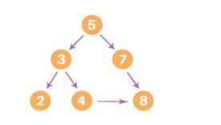
# Depth-First Search (DFS) using adjacency list

def dfs(graph, start, visited=None):
if visited is None:
visited = set()

# Mark the current node as visited
visited.add(start)
print(start, end=" ")

# Recurse for all unvisited neighbors
for neighbor in graph[start]:
if neighbor not in visited:
dfs(graph, neighbor, visited)

# ---------- Main Program ----------
if _name_ == "_main_":
# Representing the graph as an adjacency list (dictionary)
graph = {
'A': ['B', 'C'],
'B': ['D', 'E'],
'C': ['F'],
'D': [],
'E': ['F'],
'F': []
}

start_node = 'A'
print("Depth-First Search starting from node", start_node, ":")
dfs(graph, start_node)
7. Solve the given problem using python. Consider a Water Jug problem: You are given two jugs, a 4-gallon
one and a 3-gallon one. Neither has any measuring marker on it. There is a pump that can be used to fill
the jugs with water. How can you get exactly 2 gallons of water into the 4-gallon jug? Explicit
Assumptions: A jug can be filled from the pump, water can be poured out of a jug onto the ground, water
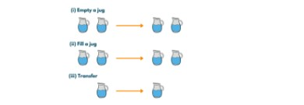
from collections import deque
def water_jug_problem():
jugA, jugB = 4, 3
visited = set()
queue = deque([(0, 0, [])])

while queue:
a, b, path = queue.popleft()
if (a, b) in visited:
continue
visited.add((a, b))
path = path + [(a, b)]
if a == 2:
print("Steps to get exactly 2 gallons in the 4-gallon jug:\n")
for step in path:
print(f"Jug A: {step[0]} gallons, Jug B: {step[1]} gallons")
return

next_states = []
next_states.append((jugA, b))
next_states.append((a, jugB))
next_states.append((0, b))
next_states.append((a, 0))
pour = min(a, jugB - b)
next_states.append((a - pour, b + pour))
pour = min(b, jugA - a)
next_states.append((a + pour, b - pour))

# Add next states to queue
for state in next_states:
if state not in visited:
queue.append((state[0], state[1], path))

print("No solution found.")

water_jug_problem()
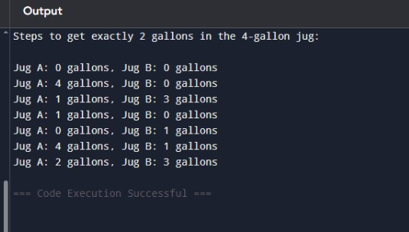
8. Implement a Python program to perform Backward Chaining on a set of Horn clauses. The program
should:
a) Accept a knowledge base defined using Horn clauses (facts and rules).
b) Take a goal (query) as input.
c) Attempt to prove the goal using backward chaining.
d) Print whether the goal can be derived from the knowledge base.

mammal(A) ==> vertebrate(A).
vertebrate(A) ==> animal(A).
vertebrate(A),flying(A) ==> bird(A).
vertebrate("duck").
flying("duck").
mammal("cat").
# ---------------------------
# Knowledge Base
# ---------------------------

# Rules: ("head", ["body1", "body2", ...])
rules = [
("vertebrate(A)", ["mammal(A)"]),
("animal(A)", ["vertebrate(A)"]),
("bird(A)", ["vertebrate(A)", "flying(A)"])
]

# Facts: simple known facts
facts = [
'vertebrate("duck")',
'flying("duck")',
'mammal("cat")'
]

# ---------------------------
# Unification function
def unify(term, fact):
"""
Unify a term with a fact.
Returns a substitution dict if successful, else None
"""
if "(" not in term: # simple fact
return {} if term == fact else None

pred1, arg1 = term.split("(")
arg1 = arg1.rstrip(")")
pred2, arg2 = fact.split("(")
arg2 = arg2.rstrip(")")

if pred1 != pred2:
return None

# If term has a variable (uppercase)
if arg1.isupper(): # e.g., A
return {arg1: arg2}
elif arg1 == arg2:
return {}
else:
return None

# ---------------------------
# Backward Chaining Algorithm
# ---------------------------
def backward_chain(goal, facts, rules, visited=None):
if visited is None:
visited = set()

if goal in visited:
return False
visited.add(goal)

# Check if goal is a fact
for fact in facts:
if unify(goal, fact) is not None:
return True

# Check if any rule can derive the goal
for head, body in rules:
substitution = unify(head, goal)
if substitution is not None:
# Apply substitution to body
new_goals = []
for b in body:
if "(" in b:
pred, arg = b.split("(")
arg = arg.rstrip(")")
if arg in substitution:
arg = substitution[arg]
new_goals.append(f"{pred}({arg})")
else:
new_goals.append(b)
# Recursively check all sub-goals
if all(backward_chain(g, facts, rules, visited) for g in new_goals):
return True
return False

# ---------------------------
# Main Program
# ---------------------------
if __name__ == "__main__":
print("Backward Chaining using Horn Clauses\n")
while True:
query = input("Enter the goal to prove (e.g., animal(\"cat\")): ")
result = backward_chain(query, facts, rules)
if result:
print(f"Goal '{query}' can be derived from the knowledge base.\n")
else:
print(f"Goal '{query}' cannot be derived from the knowledge base.\n")

cont = input("Do you want to try another goal? (y/n): ")
if cont.lower() != 'y':
break
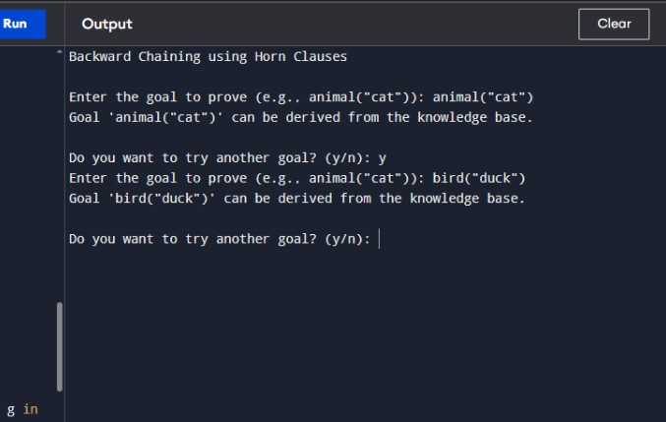
9) Implement a Python program to create a Feedforward Neural Network. The program should:
• Define an input layer, one hidden layer, and an output layer.
• Use activation functions such as Sigmoid or ReLU.
• Perform forward propagation to compute the output values.
• Demonstrate the working of the network on a small sample dataset (e.g., XOR or binary
classification problem).
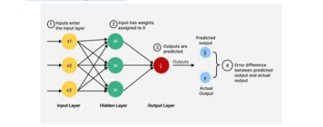
import pygame
import numpy as np

# ---------------- Activation Functions ----------------
def sigmoid(x):
return 1 / (1 + np.exp(-x))

def relu(x):
return np.maximum(0, x)

# ---------------- Feedforward Neural Network ----------------
class FeedforwardNN:
def init(self, input_size, hidden_size, output_size):
self.W1 = np.random.randn(input_size, hidden_size)
self.b1 = np.zeros((1, hidden_size))
self.W2 = np.random.randn(hidden_size, output_size)
self.b2 = np.zeros((1, output_size))

def forward(self, X):
self.z1 = np.dot(X, self.W1) + self.b1
self.a1 = relu(self.z1)
self.z2 = np.dot(self.a1, self.W2) + self.b2
self.a2 = sigmoid(self.z2)
return self.a2

# ---------------- Pygame Visualization ----------------
pygame.init()
WIDTH, HEIGHT = 600, 400
WIN = pygame.display.set_mode((WIDTH, HEIGHT))
pygame.display.set_caption("Feedforward Neural Network Visualization")

FONT = pygame.font.SysFont("Arial", 20)
WHITE = (255, 255, 255)
BLACK = (0, 0, 0)
BLUE = (50, 100, 255)
GREEN = (50, 255, 100)

def draw_network(nn, X, outputs):
WIN.fill(WHITE)

# Layer positions
layers = [len(X[0]), len(nn.a1[0]), len(nn.a2[0])]
x_spacing = WIDTH // (len(layers) + 1)

positions = []
for i, num_nodes in enumerate(layers):
y_spacing = HEIGHT // (num_nodes + 1)
layer_pos = []
for j in range(num_nodes):
pos = (x_spacing*(i+1), y_spacing*(j+1))
layer_pos.append(pos)
pygame.draw.circle(WIN, BLUE, pos, 25)
positions.append(layer_pos)

# Draw connections
for i in range(len(layers)-1):
for j, (x1, y1) in enumerate(positions[i]):
for k, (x2, y2) in enumerate(positions[i+1]):
pygame.draw.line(WIN, BLACK, (x1, y1), (x2, y2), 2)

# Draw outputs on neurons
for i, layer in enumerate(positions):
for j, (x, y) in enumerate(layer):
if i == 0:
val = X[0][j] # first input for visualization
elif i == 1:
val = nn.a1[0][j]
else:
val = outputs[0][j]
text = FONT.render(f"{val:.2f}", True, GREEN)
WIN.blit(text, (x-20, y-10))

pygame.display.update()

def main():
clock = pygame.time.Clock()
nn = FeedforwardNN(input_size=2, hidden_size=2, output_size=1)

# XOR input
X = np.array([[0,1]])

outputs = nn.forward(X)

running = True
while running:
clock.tick(30)
for event in pygame.event.get():
if event.type == pygame.QUIT:
running = False

draw_network(nn, X, outputs)

pygame.quit()

if name == "main":
main()
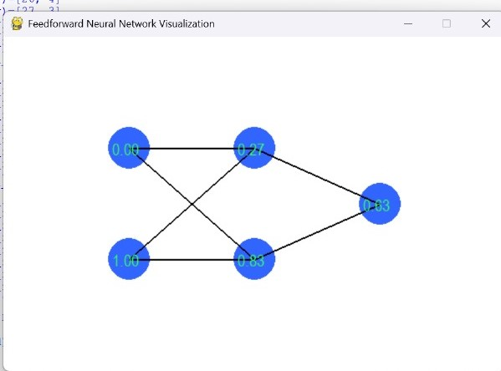
10. Implement a Python program for a Checkers AI agent using the Minimax algorithm with Alpha–Beta
pruning. The program should:
a) Represent the Checkers board and its legal moves.
b) Allow two players (Human vs AI) or (AI vs AI) to play.
c) Use Minimax with Alpha–Beta pruning for the AI’s decision-making.
d) Display the board after every move and declare the winner at the end.
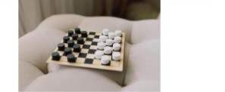

import math
import copy

EMPTY = '.'
PLAYER_PIECE = 'P'
AI_PIECE = 'A'
BOARD_SIZE = 8

def create_board():
board = [[EMPTY for _ in range(BOARD_SIZE)] for _ in range(BOARD_SIZE)]
for row in range(3):
for col in range(BOARD_SIZE):
if (row + col) % 2 == 1:
board[row][col] = AI_PIECE
for row in range(5, 8):
for col in range(BOARD_SIZE):
if (row + col) % 2 == 1:
board[row][col] = PLAYER_PIECE
return board

def print_board(board):
print(" " + " ".join(map(str, range(BOARD_SIZE))))
for i in range(BOARD_SIZE):
print(i, " ".join(board[i]))
print()

def get_all_moves(board, piece):
moves = []
for r in range(BOARD_SIZE):
for c in range(BOARD_SIZE):
if board[r][c] == piece:
moves.extend(get_valid_moves(board, r, c, piece))
return moves

def get_valid_moves(board, r, c, piece):
moves = []
directions = [(-1, -1), (-1, 1)] if piece == PLAYER_PIECE else [(1, -1), (1, 1)]
for dr, dc in directions:
new_r, new_c = r + dr, c + dc
if 0 <= new_r < BOARD_SIZE and 0 <= new_c < BOARD_SIZE:
if board[new_r][new_c] == EMPTY:
moves.append(((r, c), (new_r, new_c)))
elif board[new_r][new_c] != piece:
jump_r, jump_c = new_r + dr, new_c + dc
if 0 <= jump_r < BOARD_SIZE and 0 <= jump_c < BOARD_SIZE and board[jump_r][jump_c] == EMPTY:
moves.append(((r, c), (jump_r, jump_c)))
return moves

def make_move(board, move):
new_board = copy.deepcopy(board)
(r1, c1), (r2, c2) = move
piece = new_board[r1][c1]
new_board[r1][c1] = EMPTY
new_board[r2][c2] = piece

if abs(r2 - r1) == 2:
jumped_r = (r1 + r2) // 2
jumped_c = (c1 + c2) // 2
new_board[jumped_r][jumped_c] = EMPTY
return new_board

def evaluate(board):
player_score = sum(row.count(PLAYER_PIECE) for row in board)
ai_score = sum(row.count(AI_PIECE) for row in board)
return ai_score - player_score

def minimax(board, depth, alpha, beta, maximizing_player):
if depth == 0 or is_game_over(board):
return evaluate(board), board

if maximizing_player:
max_eval = -math.inf
best_move = None
for move in get_all_moves(board, AI_PIECE):
eval_val, _ = minimax(make_move(board, move), depth - 1, alpha, beta, False)
if eval_val > max_eval:
max_eval = eval_val
best_move = move
alpha = max(alpha, eval_val)
if beta <= alpha:
break
return max_eval, make_move(board, best_move) if best_move else board

else:
min_eval = math.inf
best_move = None
for move in get_all_moves(board, PLAYER_PIECE):
eval_val, _ = minimax(make_move(board, move), depth - 1, alpha, beta, True)
if eval_val < min_eval:
min_eval = eval_val
best_move = move
beta = min(beta, eval_val)
if beta <= alpha:
break
return min_eval, make_move(board, best_move) if best_move else board

def is_game_over(board):
return not get_all_moves(board, PLAYER_PIECE) or not get_all_moves(board, AI_PIECE)

def get_winner(board):
player_pieces = sum(row.count(PLAYER_PIECE) for row in board)
ai_pieces = sum(row.count(AI_PIECE) for row in board)
if player_pieces > ai_pieces:
return "Human Wins!"
elif ai_pieces > player_pieces:
return "AI Wins!"
else:
return "Draw!"

def play_game():
board = create_board()
print("Welcome to Checkers AI!")
mode = input("Choose mode: 1) Human vs AI 2) AI vs AI : ")

print_board(board)
turn = 'PLAYER'

while not is_game_over(board):
if turn == 'PLAYER':
if mode == '1':
moves = get_all_moves(board, PLAYER_PIECE)
if not moves:
break
print("Your available moves:")
for i, move in enumerate(moves):
print(f"{i}: {move}")
choice = int(input("Choose your move: "))
board = make_move(board, moves[choice])
else:
_, board = minimax(board, 3, -math.inf, math.inf, False)
turn = 'AI'

else:
print("AI is thinking...")
_, board = minimax(board, 3, -math.inf, math.inf, True)
turn = 'PLAYER'

print_board(board)

print("Game Over! " + get_winner(board))

if _name_ == "_main_":
play_game()
output:
